Mentoring in Practice
Process Models – Ground Rules – Techniques
Recruitment – Matching – Monitoring – Evaluation

This report has been co-funded by the European Union

Introduction
Entrepreneurship, support and employment policies. Evidence shows that access to finance alone is insufficient to ensure the sustainability, resilience and growth of micro and small enterprises, or to effectively integrate young people into the labour market. Well-designed mentoring programmes can improve business survival rates, enhance employability and strengthen social and human capital, particularly among groups facing structural barriers, such as young people, the unemployed, migrants and other underserved populations.

This mentoring manual provides a structured, practical framework for designing, implementing, and managing mentoring programmes in these contexts. Drawing on Autoocupació’s extensive experience in developing, scaling, and institutionalising mentoring initiatives across multiple regions and target groups, it supports the mentoring of young entrepreneurs, micro-entrepreneurs in crisis situations, and young people transitioning into employment. These approaches have been continuously refined through monitoring, evaluation and adaptation to changing social and economic conditions, including those posed by the challenges of the ongoing global pandemic.

The manual presents mentoring as a distinct intervention that complements financial instruments and other non-financial services, such as training and coaching. Although mentoring can support broader policy objectives, such as reducing business failure rates, improving loan performance or increasing employment outcomes, it remains fundamentally mentee-centred. Mentoring relationships prioritise the mentee's agenda, autonomy, and development, thereby contributing indirectly but sustainably to institutional and policy goals.

Rather than providing a single definition, the manual conceptualises mentoring as a voluntary, time-bound learning relationship based on trust, reflection, and non-directive support. The aim of mentoring is to strengthen individuals’ capacity to navigate uncertainty, make informed decisions, and respond adaptively to change. This approach is particularly relevant in volatile economic environments, where rigid, prescriptive support models are ineffective.

The manual covers the entire mentoring lifecycle, including the recruitment and preparation of mentors and mentees, matching procedures, mentoring processes and techniques, monitoring and evaluation frameworks, mentor training and continuous support, and programme governance. Particular attention is given to the role of mentoring managers, digital delivery models and quality assurance systems that enable scalability, accountability and alignment with recognised standards.

In addition, this guide offers tangible benefits to the key stakeholder groups involved in mentoring programmes. For mentors, it provides a clear ethical and methodological framework that strengthens mentoring practice and supports the development of non-directive and reflective skills. This framework helps mentors to navigate complex situations without taking on advisory or directive roles. For mentoring managers, the guide offers operational guidance on programme design, process management, quality assurance and mentor support. This enables consistency, risk mitigation and continuous improvement on a large scale. For microfinance institutions, the guide illustrates how mentoring can be effectively integrated as a complementary non-financial service. This service strengthens clients’ resilience and repayment capacity, enhances portfolio quality over time and contributes to social impact objectives, all without compromising the independence of the mentoring relationship.

By providing a coherent, practical methodological framework, the manual aims to support policymakers, donors, microfinance institutions and implementing organisations in strengthening the effectiveness, quality and impact of mentoring programmes. It offers transferable principles that can be adapted to different institutional settings, maintaining a clear focus on inclusion, sustainability and long-term outcomes for beneficiaries.

Process Models

3-Stage Model
A process framework to be of help for the mentee. Alred and Garvey (2019: 31) point out the model can be used in many ways:
- “To reflect upon what mentoring involves, and to assess yourself as a mentor
- As a schedule for a mentoring meeting - to work through the stages
- As a map of the mentoring process - to see what ground has been covered and what needs further attention
- To review the mentoring relationship over time, as the mentee moves towards achieving the goals identified earlier in the relationship
- To enhance shared understanding of the mentoring process and relationship, and to develop the mentee’s ability to use the model independently”



Graphic 1: 3-Stage Model, adopted from Alred and Garvey (2019: 30)

Stage 1: Exploration
The simplicity as well as the flexibility makes this model so useful for mentors and their mentees not only in the context of a pandemic but also for working with entrepreneurs and in the context of career mentoring. Stage 1 creates an opportunity to explore the well-being of the mentee, develop a deeper understanding of the mentee’s agenda for the mentoring sessions in general and for a singular meeting in particular. This phase invites to discover what is going on in the mentee’s life and business as well as offering the mentee an opportunity to reflect. Reflection can be very helpful to develop a sense of what is going on, the personal response to current events and also on individual strengths, values and principles. Thus, this allows to focus on the mentee’s agenda, helps to frame a mentoring session, allows to negotiate how the mentor might be helpful and invites the mentee to take the lead and responsibility to decide how to approach a certain topic or issue.

Stage 2: New Understanding
Quite naturally the conversation transitions to Stage 2. Developing a new or better understanding of the events and situation is a rather important step for the mentee and will make it easier to explore different opportunities and choices. Rather than telling the mentee what to do or think this stage invites the mentee to think and reflect about a certain topic or issue and arrive at their own conclusion. Additionally, this stage invites the mentee to explore to think about external factors which can contribute to deal with a situation and to overcome challenges. Research highlights the impact of external factors such as other persons who might be willing and able to help. While this is the part the mentor has the least influence over it is also the most effective form of support. During Autoocupacó’s mentoring learning events we invited mentors and mentees to share their experience and strategies dealing with current issues. Not surprisingly, mentors and mentees valued the exchange with like-minded people who found themselves in a similar situation. When asked for feedback it was the conversation with others which created a feeling of not being alone in “it” and an atmosphere where it is ok not to have the answer and rather think about potential solutions, develop new ideas through a conversation with others and being encouraged to experiment. It is critically important to allow time to go through this stage. One of the more general objectives of mentoring programmes as well as other helping professions is to strengthen the mentee’s independence and trust to address challenges adequately without the mentor, coach or therapist. Kline (2020) argues that changing or making anything for the better depends on the quality of people’s independent thinking. Independent thinking for Kline is a choice but requires an environment where the mind is stimulated by questions and the thinking and speaking is not interrupted. This thinking can positively be influenced through questions and by not interrupting the train of thoughts and words (Kline, 2020). It is this quality of independent thinking which allows the transition to taking action.

Stage 3: Action Planning
The transition towards Stage 3 does not necessarily follow a direct trajectory. It is likely to transition back and forth between Stage 1 and Stage 2. Depending on the sessions topic the mentee might need time to process the new understanding and has to let it sink in. Goals imply that the future is to some extent predictable based on previous experience. Alred and Garvey (2019) point out that sometimes the only action to agree on is setting up the next meeting and in order to take action the mentee needs to own the solution. The quality of action is firmly linked to the quality of Stages 1 and 2. Rather than focusing on quick solutions it is more helpful to explore opportunities, what is already there and potential threats as this allows the mentee to get behind the action after thinking it through. For the mentee it is more important to experience that through their actions they can get back a sense of being in control and be able to navigate through the pandemic.

Versatility of the 3-Stage Model
We noticed a need for developing a better understanding of the effects of the pandemic with regard to business-economic aspects and personal implications such as social distancing, dealing with uncertainty and general well-being. Some researchers describe that as mentors they had to come to terms with their own feelings, well-being and trying to make sense of the situation while continuing working with their mentees. Therefore such a process model needs to be able to help mentors and their mentees to structure their conversations and address the mentee’s issues adequately. Additionally, a process model has to be easy to understand and implement.

There are different ways of using a 3-Stage Model. Various issues can be address by rephrasing the different stages.
- Stage 1: Current Picture (Problems. What are my issues, concerns and unused opportunities?)
- Stage 2: Preferred Picture (Outcomes. What does a better future look like?)
- Stage 3: The Way Forward (Plans. What do I do to create this better future?)

Another variation suggest of the 3-Stage Model is the 3C-Model:
- Stage 1: Clarity – the challenges the mentee wants to address; clarity about the results they want to achieve, the things they can control in the situation
- Stage 2: Creativity – options for achieving the results, consequences of those choices, other possible creative solutions
- Stage 3: Concrete Results – conclusion related to the route they want to follow, contracting (with themselves) and commitment to achieve the results, specific actions to achieve the results.

The three process models vary slightly due to the context in which they are described. All models are designed to create a space where mentees can address their concerns, issues and problems adequately. The mentee’s agenda comes first and the process models leads to action points where the mentee reflects and decides which route to take after evaluating different choices and their consequences. The recommended approach to mentoring in this context promotes making use of a 3-Stage Model as a framework and a process model during induction trainings for mentors and mentees and when supporting organisations to implement mentoring programmes. When we work with mentors we re-introduces the model to help them structuring their sessions with their mentees. We would argue that for being effective such a linear process model brings structure, order and a sense of being in control into an otherwise chaotic, irrational world when used competently. Introducing the idea of exploration and experimentation as a significant part of the process which can lead to concrete actions was helpful for coming to terms with the current situation.

The wording of the different stages may lead to believe the model has a strong focus on addressing issues and finding potential solutions. In reality mentees are able to develop their own ideas and find adequate solutions without help from the mentor. Rather than looking for solutions mentees were looking for encouraging feedback and someone who trusted them to be successful. Exploring the variation of the 3-Stage-Model in more detail, it is easier to see that the model becomes more versatile by changing the name for each stage where Stage 1 and Stage 2 can lead to actions, where actions relate to reflection or concrete steps to explore a certain topic in more detail. More often than not, mentee’s struggled to identify a specific topic they wanted to discuss. Especially during the pandemic a wealth of issues had an impact on mentees and added to their confusion which made it difficult to formulate clearly and express their thoughts and feelings. Using the variations of the 3-Stage Model consequently has had several advantages:
- Helps to create a natural flow of the conversation.
- Allows to focus the attention on the mentee rather than thinking about the next question or a technique which might be helpful.
- It offers a whole range of different conversations driven by the mentee’s agenda.

In Annex 1 we present how we structured the induction and learning sessions for mentors and mentees. We would strongly suggest to offer these learning modules to mentors and mentees! Both, mentors and mentees benefit from a better understanding of the processes involved.

GROW
Whitmore (2017) has developed a 4-Stage Model, GROW; which he introduced in 1992. Since then GROW has been used successfully in various performance oriented settings, i.e. sports coaching. The sequence starts with exploring goals and ambitions of the coachee, explores what the perceived reality looks like, what options are available and explore the effort and commitment needed to achieve those goals.
- “Goal – What do you want?
- Reality – Where are you now?
- Options – What could you do?
- Will – What will you do?” (Whitmore 2017: 108)

Whitmore explicitly encourages to use the sequence with questions rather than telling coachees what to do and also underlines the importance of giving coachees a choice and allow them to set their own goals. Some researchers and practitioners argue that setting goals is a relevant part of coaching and mentoring to advance the mentee’s agenda. Others suggest a more cautious use of goals. One of the objections is the issue of failing and the negative related effects. Goals by definition have a timeframe. In a situation where the mentees have been unable to predict the future and have had very limited control over it, setting goals is of limited use and will likely lead to more frustration and the loss of hope. We suggest to understand that goals have a “dark side” and raise the question of whose agenda they actually serve.

While the GROW model is largely popular it should be used with caution. The focus of the model is on performance and goal orientation. Breaking down goals into small, actionable steps helps to focus on what is important. However, such focus can lead to overlooking or neglecting the element of surprise, unpredictability and unexpected and how to deal with them adequately. Probably, it is the business-economic driven interest to be able to control and manage as well as execute a plan where the model shows its strength. However, predicting or controlling the future in the context of working with NEETs might be of limited use for the mentee.

We added the GROW model to this guide as it is widely used. However, in our mentoring practice we hardly ever use it.

Effectuation Process
Sarasvathy (2001) distinguishes between causation and effectuation processes. Causation processes follow the more traditional business-economic logic which are at the core of business plans. The desired outcomes are defined and the necessary resources, i.e. money, knowledge, staff, are used to achieve such results. Effectuation processes start with means the entrepreneurs already have and depend on the quality of interactions with self-selecting stakeholders, i.e. potential or existing customers, other actors (entrepreneurs). Decisions are based on affordable loss or acceptable risk. Through these interactions entrepreneurs create a new set of means. A key element of the process is to expect the unexpected and to embrace the element of surprise which results from interactions with stakeholders. Actors in the same sector are not considered to be competitors but rather potential business partners. The effectuation process becomes more relevant when the future cannot be predicted.

“Causation processes focus on the predictable aspects of an uncertain future. The logic for using causation processes is: To the extent that we can predict the future, we can control it. Effectuation, however, focuses on the controllable aspects of an unpredictable future. The logic for using effectuation processes is: To the extent that we can control the future, we do not need to predict it.” (Sarasvathy, 2001: 252)

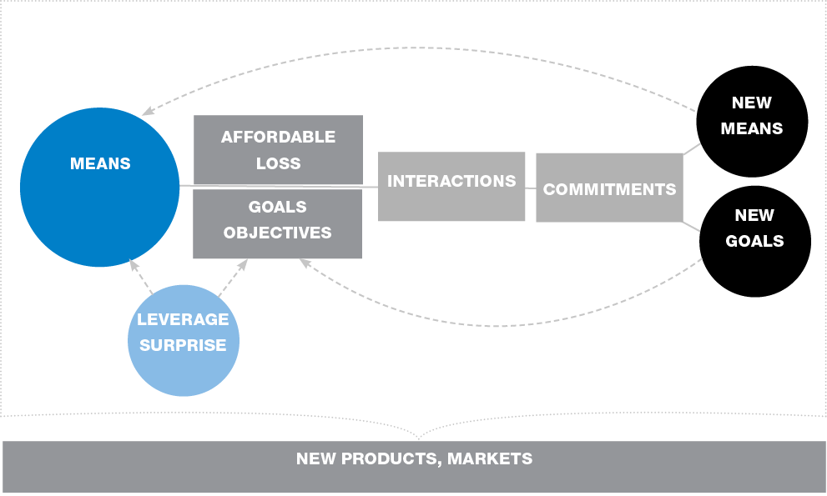
Effectuation Process: adopted from www.effectuation.org

We use this process as an additional layer of the 3-Stage Model where each element of the effectuation process starts with exploration, i.e. of means, affordable loss, people to contact etc., with the aim to arrive at a new understanding of what new markets or products could look like and finally to commit to concrete actions.

Such a process can help to focus on the controllable aspects of the mentee’s life and career or business and reduces some of the stress induced by not being able to predict the future. More importantly though, effectuation processes encourage the mentee to find support outside and develop new means and resources will significantly increase the effectiveness of the mentoring relationship. Research estimates that with support from the outside clients will do better than 95% compared to those without such support (control group).

The value of the Effectuation process in practice is that it is a good fit in combination with the three variations of the 3-Stage Model and it helps to
- Explore and clarify the agenda of the mentee
- Explore the mentee’s means and resources which are readily available to them
- Take action
- Explores new opportunities collaborating with others and by that helps to build-up external support
- Encourages to explore and develop new markets and products in collaboration with customers
- It includes the element of surprise and new developments and rather than seeing that as a threat it focuses on the opportunities.

Recommendations
We suggest to prepare mentees and mentors for their role. To this end we have developed a series of learning opportunities which we added to this guide in Annex 1. Based on the social practices and the social context in which mentoring takes place, we recommend to adjust the mentoring learning opportunities accordingly. We only match mentor and mentees who have completed a mentoring induction. In general, the induction training takes 2 to 3 hours and can be delivered in a classroom or virtually.

Ground Rules: Purpose and Function

Ground Rules: Purpose and Function
In general ground rules are critically important in any mentoring relationship. It is essential that both sides discuss the objectives of the mentoring relationship, clarify the expectations of each other and how they will manage the relationship. We suggest to agree on and clarify ground rules to establish a successful relationship where each party understands what is expected of them so they are able to play their roles in the relationship. Garvey (2018: 19; 1994: 18) suggests a dimensions framework to establish ground rules.
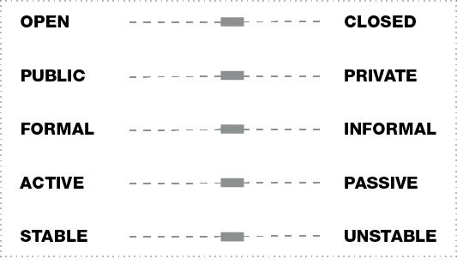
Garvey’s Dimension Framework

- On the open–closed dimension the pairs clarify the topics to be discuss, which are included and which are off-limits. An open relationship includes all topics whereas a closed one excludes certain topics.
- On the public–private dimension the pairs clarify who should be informed and possibly included in the relationship. In a public relationship other people know that the relationship exists whereas in a private one others are not aware of it or only a very limited number of people, i.e. the mentoring relationship manager.
- On the formal–informal the dyads agree to meet regularly or when necessary, to follow a certain agenda or to discuss topics as they become relevant for the mentee. The formal refers to agenda, schedule rather than to the character of the relationship.
- On the active–passive dimension the pairs clarify their roles. This includes the expectation of how active or passive the mentor is supposed to be. It also includes interventions of the mentor on behalf of the mentee.
- The stable–unstable dimension refers to the behaviour of both parties regarding predictability of behaviour and security. Consistency and regularity help to create an atmosphere of psycho-social stability and trust.

We suggest not to assume but to actively clarify the different dimensions. Garvey (1994) demonstrated that these dimensions are not static and change over time. Hence, it is important to re-visit and re-negotiate the different dimensions of the ground rules as the relationships change over time. Based on the recommendation of researchers and practitioners, we suggest to negotiate the agenda during Stage 1 of each session. This is also a good opportunity to explore and clarify the different dimensions and roles. Ground rules help to create an environment in which learning is encouraged, they also contribute to enable mentors and mentees to be at ease and trust the process being an integral part of the process model.

Ground Rules: Evaluation
During mentor induction trainings, we noticed a certain insecurity among mentors when they were not sure about what their role is, if they are expected to take a more active part in the conversation for example. This can lead to some unwanted behaviour on the side of mentors where they jump in too early and offer advice, share their experience or present potential solutions to a problem identified by the mentee. In an adult learning environment it is critically important to allow mentees to arrive at their own conclusion, develop trust in their decisions and by that become independent from the input of their mentors.

Reflecting on their practice, mentors reported that if they did not carefully clarify how they as mentors could help to address a particular issue and how active or passive the mentee expected them to be, they regularly found themselves in a situation where they were unsure whether the sessions were helpful to the mentees. While mentees, when asked, reported back that the session were useful or somewhat useful it left the mentors with a rather uncomfortable feeling. Being too active or contributing to solutions too early and too soon took away a great deal of learning opportunity from their mentees. Additionally, any form of advice, shared experience and contribution to solutions of the mentee’s issues take away the opportunity to develop their own solution, trust their thinking and by that improve their self-esteem as well as strengthen their independence. After discussing this issue in more detail mentors included a contracting sequence into Stage 1 as part of the exploration. Doing it this way felt very natural and does not impact the flow of the conversation negatively.

Research suggests that the quality of the working alliance contributes significantly to the effectiveness of the intervention where 69% of the relationships are more effective compared to a control group. Creating an atmosphere where learning is a social activity and can be transformational rather than just transactional has been especially valued by mentees. Some researchers describe that mentors became a “lifeline” for their mentees during the pandemic. The feedback we received from the mentees was that they really appreciated having that one person who showed up, didn't leave and listened to their concerns and ideas. Using virtual meetings creates another dimension which needs to be addressed. By using video calls we invite the other one into our living rooms, kitchens – into our homes. This can create an issue on the open/closed aspect and has to be considered with regard to gender and different cultures and norms.

Garvey (1994) highlights two relevant aspects. There is a probability that the dyads have different perceptions on the nature of their relationship which can create issues. For an effective working alliance it is important that both parties have the same understanding of the different dimensions of their relationship. In practice we noticed that with the same mentee the ground rules can change quickly where during one session it can be an open conversation and in another certain topics are excluded depending on the mentees willingness to address them. Therefore, we find it good practice to re-negotiate what is in and what is out. Our approach to mentoring strongly encourages to implement a mentoring programme manager (MPM) who is the main point of contact for the dyads. A MPM can check-in regularly and evaluate whether the relationship is working or not and offer support when needed. Especially, when the pairs have a different understanding of the dimensions framework they able to address such issues effectively.

Recommendations
The nature of the mentoring relationship changes over time. Mentoring programmes benefit significantly from implementing a mentoring manager (MPM) who monitors the relationships, offers additional support directly or by engaging relevant expertise (i.e. from other mentors). As the mentoring relationship develops the ground rules need to be re-negotiated or can be a reason for failing working relationships. MPMs can help to avoid misunderstandings through monitoring and evaluation and bring in external expertise if the dyads feel it necessary.

Skills and Techniques

Techniques, Skills and Choices
Some practitioners and researchers encourage mentors to build their own library of techniques. However, they also argue that using techniques may develop a dynamic where the technique becomes more important than the mentee’s agenda. A technique might not be suitable for the mentee’s learning style or focus too narrowly on one issue, i.e. decision making. Therefore, techniques have to be selected carefully by mentors and used in line with the chosen process model and the intended output and outcome of the related stage of the process model.

One of the observations we made when training mentors is that there seems to be an unquenchable thirst for techniques. It could be argued that for mentors it can be helpful to have a wealth of different techniques at their disposal as long as they have practiced them and are able to use them expertly. It seems to be good practise as a mentor to make use of techniques to help advance the mentee’s topic, to think something trough to arrive at a new or better understanding of their own and in their own time. Taking the time to create an atmosphere in which such thinking is possible, what Kline (2020) calls a thinking environment, is less a technique than an active choice. It is fair to say that listening, asking questions, empathising and being present is a choice. And it is this choice that helps to establish the relationship, build rapport and trust, and thereby form a stable and effective working alliance, which contributes significantly to the success of a mentoring relationship.

Time to Think
Creating a container of psychological safety is at the heart of Kline’s (1997) Time-to-Think model. It is based on the assumption that our minds work best in the presence of questions. Kline argues that the quality of our actions depend on the thinking we do first and our thinking depends on the quality of attention for each other. Paying “beautiful attention” to the thinker requires to be present and to focus the attention on the thinker. The model offers time and a safe space where the thinker is invited to develop their own thinking and arrive at their own conclusions. Reflecting on mentoring sessions mentors might be surprised by the quality of their mentee’s thinking and how much they are able to solve issues on their own. Kline’s model is a valuable example of a technique which can be easily used in a mentoring conversation but which needs practice and experience to encourage independent thinking.

Dialogic Choices
A core skill of mentors is being able to ask questions which help and encourage the mentee to think differently. Garvey suggests eight different dimensions of questions:
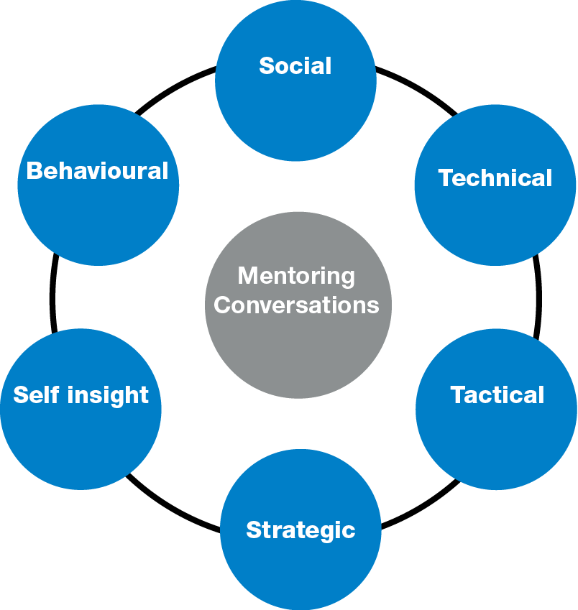
Garvey: Dialogic Choices

Depending on the mentee’s agenda a mentor can guide the conversations and help the mentee to explore different aspects of an issue. Asking questions on the social dimension allows the pair to establish rapport. Asking questions related to the technical, tactical and strategic dimension can help the mentee to explore and develop a new understanding of a certain situation. Questions on the behavioural and self-insight dimension can be an invitation for the mentee for reflection. The value of these dialogic choices for mentors are that they can help to structure the conversation and systematically think through complex issues. Again, it is a choice mentors can make to ensure that the conversations are not always around topics where they feel most comfortable but help to advance the agenda of the mentee. It also allows to explore blind spots or issues mentee’s might not be aware of. Obviously, exploring the unknown needs explicit permission from the mentee.

Effectuation Principles
Sarasvathy (2008) has developed five principles based on semi-structured interviews with successful entrepreneurs:
- Bird-in-Hand Principle: Entrepreneurs start with means they have, people they know, knowledge they have
- Affordable Loss Principle: Entrepreneurs determine how much they want and actually can risk to pursue a goal
- Crazy Quilt Principle: Entrepreneurs set out to build a network of self-selecting stakeholders which contribute to achieve their picture of success
- Pilot-in-the-Plane Principle: Entrepreneurs take actions based on the assumption that waiting for others or the situation to change is not helpful pursuing their goals and objectives
- Lemonade Principle: Entrepreneurs are aware that things change, they embrace surprises and expect the unexpected

Especially the first three principles, Bird-in-Hand, Affordable Loss, Crazy Quilt, have been very helpful for mentees in the context of entrepreneurship before and during the pandemic.

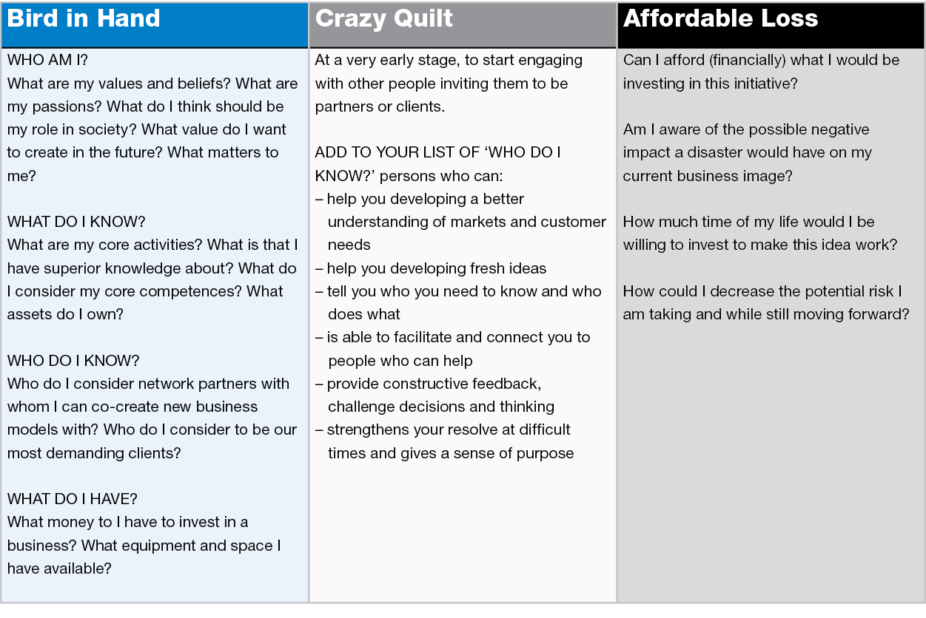
Effectuation Principles: adapted from www.effectuation.org

The Effectuation Process and the related principles focus on the mentee’s agenda and can help to address a wide range of issues. Quite often mentees are their biggest critics which sometimes obstructs the view on their achievements, their skills, values and motivations. As Kline (2020) argues, it should be the mentees discovering these things on their own. One of the most important aspects of using these principles as a technique during mentoring is that it has an element, the Crazy Quilt principle, which encourages the mentees to actively build relationships and assets outside the mentoring relationship and by that strengthening their independence.

Recipes – combining different techniques
In this section we would like to offer an example of how to combine different ideas. It might be helpful to think of it as recipes. Rather than thinking of techniques as standalone applications it might be more helpful to use them in combination with a process model and other techniques. So rather than using one specific technique they might be more useful when combined with others.

The (real) story of an entrepreneur who was overwhelmed by the situation may serve as an example. To help the entrepreneur to focus on what he can control and influence Covey’s (2020) Controlling the Controllables model (Circle of Influence) was used in a first step, then the mentor suggested to formulate action points in an action plan and in a last step evaluate his motivation to execute the plan using a scaling techniques. The tasks looked like:

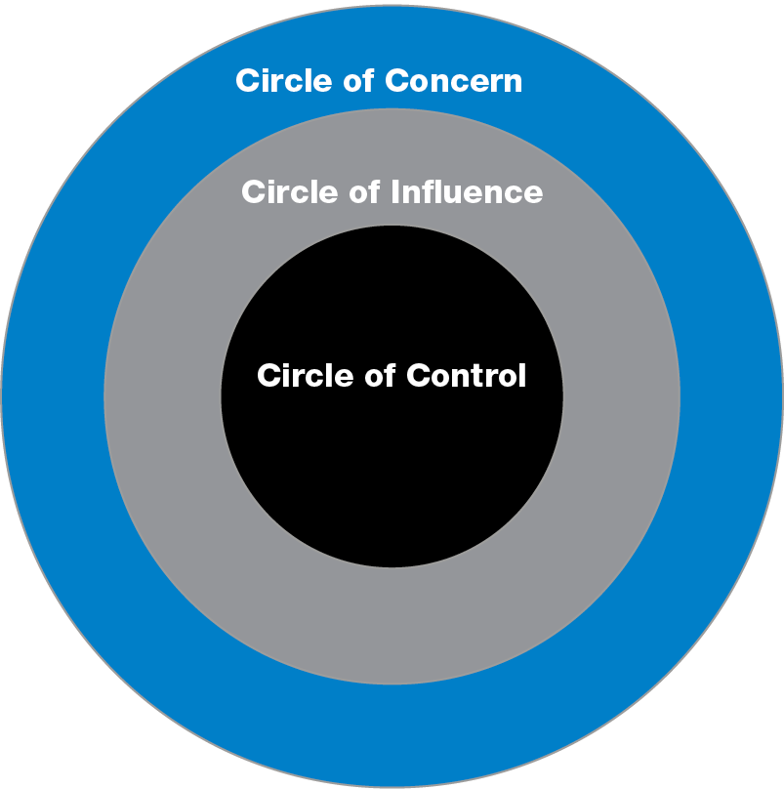
Circles of Influence & Control

Step 1: Write down what’s on your mind?
This task relates to Stage 1: Exploration.
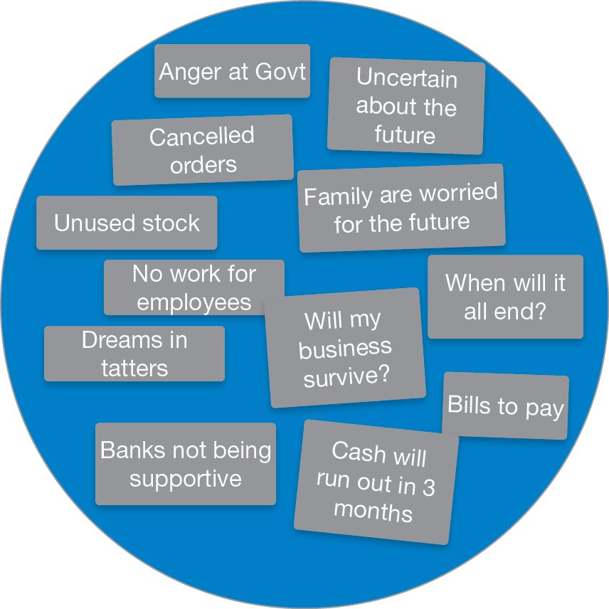
Circle of Concern

Step 2: place those issues you can CONTROL in the Circle of Control and those you can INFLUENCE in the Circle of Influence. These steps are related to Stage 2: New Understanding.
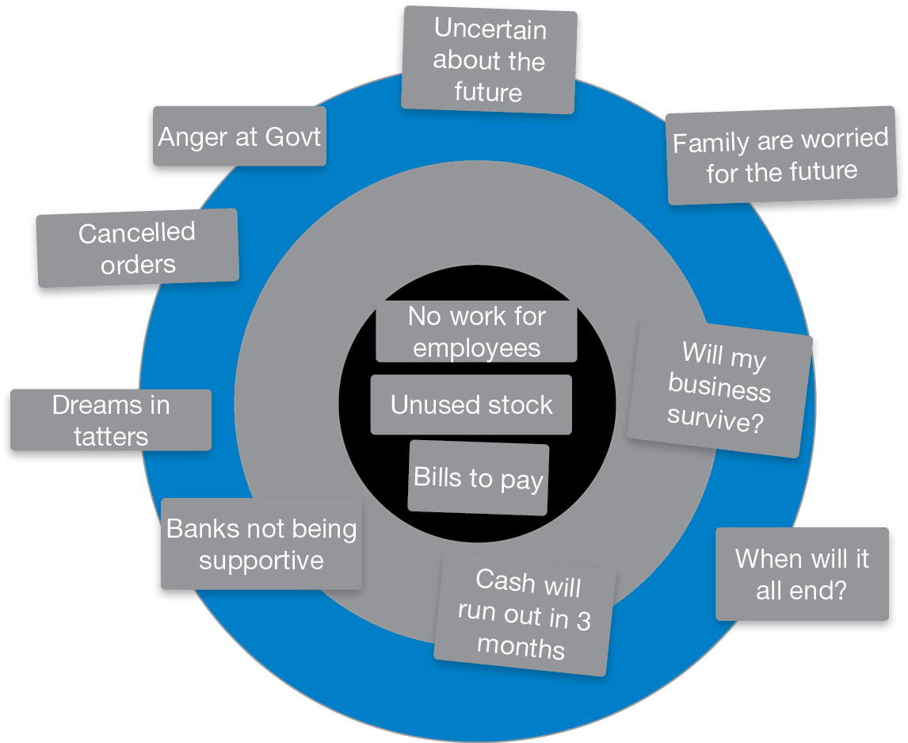
Circles of Influence & Control

Step 3: Action Plan, where the Circle of Control has top-priority; Circle of Influence needs to be addresses as soon as possible, Circle of Concern will be addressed when there is time. These tasks are related to Stage 3: Action Planning.
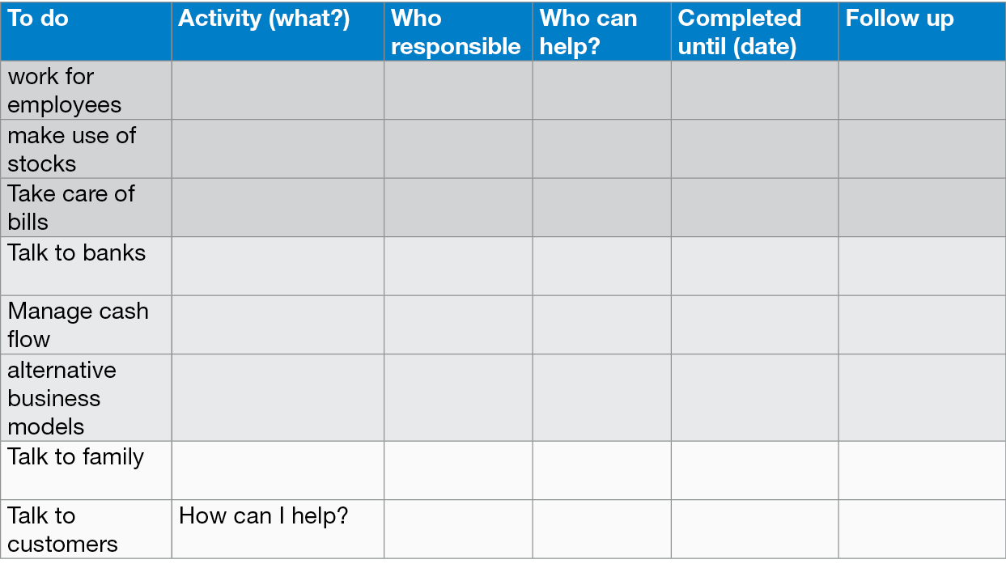
Action Plan

Step 4: Scaling: On a scale from 1 to 10 – how likely is it that you execute the plan, where 1 is “over my dead body” and 10 is “I am utterly committed to this!)
This example may serve to illustrate the relevance on having a solid foundation using a process model such as the 3-Stage Model. Stage 2 can be used to evaluate the different choices and suggested actions points rather than loosing focus of the overall process an being distracted by the various techniques.

Remote Mentoring
COVID-19 related restriction, such as social distancing the need to work remotely, required shifting to remote mentoring sessions. This required to review techniques against whether such techniques can be used during phone or video calls. The technology is readily available to support remote mentoring and virtual collaboration, i.e. miro.com or mural.com, which allow to make use of templates for a whole range of topics. In the context of mentoring for enmtrepreneurs, techniques are based on Design Thinking and Lean Strat-Up approaches and allow the dyads to make use of them. While the technologies to support remote mentoring exist they can distract from the mentoring process itself where the technology and the techniques used become too dominant and distract so that the focus of attention shifts from the mentee to the technology. Another aspect to be considered carefully is that the use of such technologies asks for rather good and stable internet connections, sufficient data volume, powerful computer and tablets. Especially low income communities still struggle with such requirements. Therefore, the choice of techniques needs to be considered against the technology the mentee has access to rather than what is readily available.

Recruitment

What are the criteria to become a mentee?
Mentees have to attend an induction training. During the induction training mentees will learn about the different roles in mentoring, mentoring processes and techniques, their responsibilities, what to expect from a mentor, the matching process, monitoring and evaluation and the support from the mentoring manager. After induction training mentees will complete the mentee profile and be available for a 30’ interview to clarify their needs and expectations.

Eligibility criteria:
- Commitment to working with a mentor.
- Accessible, reliable and able to meet commitments.
- Be proactive.
- Be prepared to give (and receive) feedback.
- Be honest.
- Be open to new learning opportunities.
- Understand that your mentor does not have all the answers.
- Time commitment: 3-4h per month over a period of 3–6 month

What is the motivation to work with a mentor?
- Improved/new/alternative business model
- Improved job search and job application skills
- Avoid mistakes/make better decisions
- Honest feedback/sounding board/safe space
- Improve/build professional networks
- Learn from experienced entrepreneurs
- Personal development
- Balance personal and professional life better
- Developing resilience, deal with uncertainty

What are the criteria to become a mentors?
- Good communication and interpersonal skills
- Commitment to working with a mentee and values of the programme
- Capable of developing the skills of entrepreneurs to make strategic business decisions for themselves
- Ability to maintain appropriate boundaries while providing valuable guidance during business start-up
- Be motivating, be patient
- Ability to work with people who are likely to have different views and experiences
- Providing positive and constructive feedback and challenging assumptions
- Ability to relate and empathise with women and their aspirations
- Good listening and observation skills
- Accessible, reliable and able to meet commitments
- Entrepreneurship experience, i.e. owner/manager, managing projects
- Marketing and/or financial management experience
- Entrepreneurship background is desirable
- Experience in career management, HR (career mentoring)
- Sector specific knowledge
- Time commitment: 2-4h per month over a period of 3–12 months

What is the motivation to become a mentor?
During the recruitment and registration process we ask volunteers why they want to become mentors. Mentoring is a social activity and at its core it is two-way-learning relationship. Below is list of typical reasons why volunteers decide to become mentors:
- “Although this question asks for personal reasons, professionally, I am keen to understand how our community programmes can support micro and small business owners through mentoring. I would like to extend mentoring as one of the interventions in many of the programmes should it deem fit.”
- “Personally, I would like to meet people from different background and be inspired.”
- “This project is a great way to give back to the community.”
- “I would like to contribute to the society and help someone by mentoring / coaching them in their journey.”
- “Learning. Always learning. Regardless of what position I’m in – mentee or mentor.”
- “My motivation to become a mentor comes from my positive experience in being a mentee. I want to share what I’ve got.“
- “Like most mentors, I would like to be able to support another individual have clarity on issues and decisions they face in their business. I have always received some sort of support and would be happy to do the same for others.”
- “Because we all have something, we can learn from each other, I am hoping to learn and to increase my network.”
- “Firstly, I would like to pay it forward. I have been privileged to have great mentors around me who have guided me throughout my career and personal journey.
- “I believe I have acquired some skills that are transferrable and hopefully will help the next generation of women prosper.”

Screening & Selection
Screening and selection is one of the most important processes within a mentoring programme. Screening is a process performed by the organisation to ensure that the right match is made between the work to be done and the person who will do it. A robust screening and selection process will help to ensure that the volunteers are a) suitable for the mentoring role by meeting the established criteria and b) are safe to work with your entrepreneurs. Criteria for interviews

An application form collects basic information - name, address, experience - while giving the organization permission to do reference checks and police records checks (if necessary). Asking volunteers to complete an application form signals the seriousness of an organization's commitment to screening and provides a paper trail that will protect both the volunteer and the organisation.

Mentors and mentees will be invited for interviews if they have:
- Completed the induction training
- Completed the mentor/mentee profile (Annex 3 and 4)

Template letter for those attending interviews
As we intend to follow up with interviews directly after the mentors/mentees completed the induction training and mentor/mentee profile the mentoring manager will send an email to arrange for a 30 minutes interview.
Dear [Name of applicant],

Thank you for taking the time to complete the mentor /mentee profile for the position of Volunteer Business Mentor with [name of programme] mentoring programme. We would be delighted if you could attend a thirty minute discussion meeting to discuss the role and to meet a member of our team.
Please email me at mentoring@kiz.de at your earliest convenience, and I would be pleased to arrange a mutually convenient time and date with you.
Our Volunteer Business Mentors are vital to the success of our entrepreneurs and we look forward to meeting you to learn more about how you can support us.
If you have any other queries, please feel free to contact me.
With my best wishes,
[Name/Position]
[Name of organisation]

Matching
Matching is a key part in the overall design of a mentoring programme and needs to be clearly defined and agreed to up front. Matching is often the stage in mentoring that people ask the most questions about, and have the greatest expectations from. The more transparent you can be about how the matching process works, the greater commitment you will get from participants. Matching is not an exact science and it often relies on ‘gut instinct’ or intuition based on the information the Mentoring Manager has gathered. The more similarities mentors and mentees have, the easier it is to establish a good working relationship and build trust. The greater the differences, the more opportunities there are to learn from each other.

Matching – an imperfect art, not a science
A successful mentoring relationship requires the right mix of chemistry, knowledge and skills and is as much an art as it is a science. Some researchers and practitioners argue that successful matching occurs when the mentee and mentor share a similar value and belief system. Matching is therefore a key part in the overall design of a mentoring programme and needs to be clearly defined and agreed to up front. The more transparency there is in how the matching process works, the greater commitment the organisation will get from participants.

Sometimes we see mentoring managers who try to make the perfect match based on personal and professional characteristics. We recommend to interview both, mentor and mentee and share the respective profile. Additionally, the rationale for the match should be shared. In our experience, mentors and mentees have an interest in making the relationship work. We recommend to kick-off the relationship by asking the dyads to work together for three sessions and if the match does not feel right, the mentoring manager will look for a different match (no fault divorce clause).

Minimum Standards
The mentoring programme considers the relevant characteristics of the mentor and mentee when matching (skills, geographical area, gender, personality, availability, preferences of the mentor/mentee). Where possible, mentors and mentees have an input into who they will be paired with.
There are processes in place to manage a match that does not work. The mentor and mentee have been provided with a briefing before their first meeting. Mentor, mentee and if possible the mentoring manager sign a Mentoring Agreement which consents to the programme’s requirements (e.g. roles, meeting frequency, reporting requirements, expectations etc.).

The match provides appropriate learning opportunities for both the mentor and mentee. The time between training and matching does not exceed two months. Mentors and mentees are kept informed if the match takes longer than expected. The matching process is reviewed regularly to ensure feedback is integrated back into the programme.

Enhancements
The Mentoring Manager facilitates the first meeting between the mentor and mentee. The Mentoring Manager follows up with the mentor and mentee after they have had two to three meetings to understand whether the match has worked out. Mentors and mentees are given a “no fault divorce” clause or “graceful exit” clause should the relationship not work out after the first few meetings.

Matching criteria
Relevant matching criteria are whether the mentor’s experience fits with the mentee’s needs. Other criteria to take into consideration include:
- Shared values and beliefs (compare Annex 3 and 4)
- Availability
- Learning styles
- Skills/expertise
- Location
- Entrepreneurship experience
- Sector specific knowledge
- Experience gap
- Interests (compare Annex 1 and 2)

Monitoring
Monitoring of the dyads allows to determine whether the relationship is working successfully and identify potential problems at an early stage. The mentoring programme manager offers additional support to mentors and mentees in case the need arises. This could be offered by engaging other mentors of the programme or by facilitating contacts to other entrepreneurs who either deal with the same challenges or have already solved them. Monitoring also allows to evaluate the performance of the relationship and assess goals (i.e. developing entrepreneurial skills and personal development). The monitoring mail should invite mentors and mentees to complete a form. Completing the form, which can be created with Google Forms, Microsoft Forms or Survey Monkey, should not take longer than 5 minutes. The suggested monitoring process actually takes 2 minutes to complete. It is more important to get high participation rather than evaluating outputs and outcomes at this time. A more in depth analysis should be conducted every three month or, at a minimum, every 6 months.

The mentoring programme manager follows up directly on dyads who did not participate in the monitoring process. For the follow-up phone calls and text messages are more effective than emails. It is important to develop an understanding of the status of the relationship:
- Have the dyads met?
- Is the matching working for both parties?
- Are there any issues that need to addressed?

Monitoring requirements
All mentors and mentees agree to participate in the monitoring process. Every month the mentoring programme manager will send a monitoring email with a link to a form of five questions:
1. How useful were the last meetings with your mentor?
a. Very useful
b. Useful
c. Less useful
d. Not useful

2. How satisfied are you with the cooperation with your mentor?
a. Very satisfied
b. Satisfied
c. Less satisfied
d. Not satisfied

3. How often did you meet with your mentor?
a. More than 4h per month
b. 2h - 4h per month
c. Less than 2h per month

4. Did you focus on hard skills (strategy, financial planning, marketing & sales) or soft skills development (project and time management, presentation, communication, dealing with stress, grit, confidence, setting goals)?
a. Focus on Hard-Skills
b. Focus on Soft-Skills
c. We work on business related and personal topics

5. Comments (anything you would like to share with us?)

Evaluation of monitoring forms
One of the main objectives of the monitoring process is to assess whether the dyads have formed a working alliance. A good working alliance contributes with 69% to the effectiveness of the mentoring relationship compared to a control group. Relevant in this context is the opinion of the mentee. Therefore, we suggest to evaluate carefully, especially during the early stages of the mentoring relationship, whether or not the dyads found a common basis for their collaboration. As a rule of thumb, we can safely assume that the mentee will be very satisfied with the mentor:
- When the mentee’s agenda is at the forefront of everything
- When challenge and support are balanced right according to the mentee’s needs
- When the mentor follows a non-directive approach

Question 1: A subjective feedback from mentee and mentor help to understand the quality of the working alliance. Usefulness can be interpreted as an indicator that the relationship is working and the mentee and mentor get something out of it. Any feedback in the area of “Less useful” or “Not useful” would require a follow-up call by the mentoring programme manager as this should be treated as a dysfunctional relationship.

Question 2: The cooperation between mentee and mentor is critically important as mentioned earlier. A good working alliance is a key success factor in mentoring. Any feedback indicating “Less satisfied” or “Not satisfied” needs immediate intervention. In our experience it is helpful to re-visit the different dimensions of ground rules and expectations. A positive feedback “Very satisfied” and “Satisfied” indicates a working alliance which will very likely lead to satisfactory outcomes.

Question 3: The frequency of meetings is a good indicator to follow-up and very the feedback from Question 1 and 2. At a minimum meetings of 2h–4h per month should be expected. Less than 2h per meeting requires a follow-up. While it is quite a common phenomenon that dyads have times with less frequent meetings, mentoring during a pandemic would require at least 2 meetings per month.

Question 4: A focus on hard skills can indicate that the relationship between mentor and mentee is at an early stage. Only when trust and rapport between the dyads has been established more personal issues will be discussed. Personal issues are sometimes related to soft skills and personal development.

The mentee’s agenda should always have priority and it should be the mentee who sets the agenda. It is the mentor who helps the mentee to address their topics adequately. However, mentors will have a preferred approach to mentoring. Especially in the early stages of the relationship a focus on more technical, tactical and strategic topics can be expected (see section 4.3). As the relationship between the dyads develops more personal topics will be addressed. Such a development can be identified through Question 4.

Question 5: This section should be used to provide an opportunity to share feedback and ask questions, i.e. for additional support. In practice Question 5 is used more often to feedback on the quality of the matching and the working alliance in general. Thus, it offers more insights and helps the mentoring programme manager to assess the quality of the relationship.

Evaluation
This section intends to provide an overview of how to evaluate a mentoring programme. We recommend to invest some time during the design phase of the programme to design a theory of change and how to assess the outcomes and impact of the programme. Regularly, sponsors of mentoring programmes expect to see quantitative and qualitative data collection. For the quantitative data collection we would like to offer some ideas and possible solutions. For the qualitative data collection, we would recommend an Interpretive Phenomenological Analysis and/or focus group interviews. We found it helpful to collaborate closely with academics and researchers who specialise in impact assessments.

The evaluation process is designed to be implemented by the mentoring programme. It tries to capture two main outcomes:
- The outcomes of the intervention (satisfaction, usefulness)
- Suggestions to further improve the mentoring programme

Depending on the objectives and targets of the programme it is worth collecting additional information and data (KPIs). Some are more related to the mentee and mentor, some are related to the overall programme:

Programme related KPIs:
- Number of mentees engaged (i.e. through training)
- Number of mentees disaggregated by gender (women/men)
- Number of mentors engaged (i.e. through training)
- Number of mentors disaggregated by gender (women/men)
- Number of matches
- Number of matches disaggregated by gender (women/men)
- Number of active relationships
- Average duration of the relationships
- Average number of hours of mentoring per match

Evaluation form for mentees
- How would you rate the usefulness of the mentoring programme in helping you to manage, sustain and grow your business/securing a job?
- Very useful
- Useful
- Less useful
- Not useful

- How do you rate the working relationship with your mentor?
- Very useful
- Useful
- Less useful
- Not useful

- How often did you meet with your mentor?
- Weekly
- Every 2 weeks
- Monthly
- Every 2 months
- Quarterly

- How do you rate the frequency of the meetings?
- Very useful
- Useful
- Less useful
- Not useful

- Do you feel that the mentor is responsive and available to assist you when you need them?
- Always approachable and available
- Usually approachable and available
- Sometimes approachable and available
- Never approachable and available

- How do you rate the mentor's willingness to address your needs, concerns or worries on a scale from 1-10?
(where 1=not very willing and 10 always willing to address my needs, concerns or worries)
Natural number

- Do you think that your mentor has the right skills and experience to help you?
- Very useful
- Useful
- Less useful
- Not useful

- How do you assess the evolution of your business/career since working with a mentor on a scale from 1-10?
(Where 1=no significant development and 10=quick and sustainable development of my business)
Natural number

- Please tell us to what extent mentoring has influenced you:
Text field

- What significant changes have occurred in your business since you have worked with your mentor?
Text field

- How would you evaluate the future of your business/professional life?
- Very optimistic
- Somewhat optimistic
- Not very optimistic
- Pessimistic

- How likely is it that you will continue trading (this question is for mentoring entrepreneurs)?
- Very likely
- Somewhat likely
- Not very likely
- I did end trading

- In your opinion, where have you improved your professional and personal skills?
Management (corporate) |  | Employees / Recruitment / HR
Business planning |  | Accounting, bookkeeping
Business strategy; business models |  | Tax related issues
Product and product development |  | Legal issues
Marketing/PR |  | Information and communication technologies
Digital Marketing |  | Web/Search Engine Optimization
E-commerce |  | Financial management
Sales |  | Access to finance
Customer development/ customer relationships |  | Time- and self-management
International trade |  | Building professional networks
Social entrepreneurship |  | Working with others
Decision making |  | Resilience
Career planning |  | Job search strategies
Other (please specify)

- On a scale from 1-10, how likely is that you would recommend other entrepreneurs to work with a mentor?
natural number

- In your opinion, how might we improve the mentoring programme?
Text field

Evaluation form for mentors
- How would you rate the usefulness of the mentoring programme in helping your mentee to manage, sustain and grow their business/professional career?
- Very useful
- Useful
- Less useful
- Not useful

- How do you rate the working relationship with your mentee?
- Very useful
- Useful
- Less useful
- Not useful

- How often did you meet with your mentee?
- Weekly
- Every 2 weeks
- Monthly
- Every 2 months
- Quarterly

- How do you rate the frequency of the meetings?
- Very useful
- Useful
- Less useful
- Not useful

- Do you feel that the mentee is responsive and available to work with you?
- Always responsive and available
- Usually responsive and available
- Sometimes responsive and available
- Never responsive and available

- How do you rate the mentee’s willingness to address their needs, concerns or worries adequately on a scale from 1-10?
(where 1=not very willing and 10 always willing to address my needs, concerns or worries)
Natural number

- Do you think that you have the right skills and experience to help your mentee?
- Very useful
- Useful
- Less useful
- Not useful

- How do you assess the evolution of your mentee’s business since you have started working together on a scale from 1-10?
(Where 1=no significant development and 10=quick and sustainable development of my business)
Natural number

- What have you learned from your mentee?
Text field

- What significant changes have occurred in your mentee’s business/professional life since you have worked with your mentee?
Text field

- How would you evaluate the future of your mentee’s business/career options?
- Very optimistic
- Somewhat optimistic
- Not very optimistic
- Pessimistic

- How likely is it that your mentee will continue trading (for entrepreneurs only)?
- Very likely
- Somewhat likely
- Not very likely
- I did end trading

- In your opinion, where has your mentee improved their professional and personal skills?
Management (corporate) |  | Employees / Recruitment / HR
Business planning |  | Accounting, bookkeeping
Business strategy; business models |  | Tax related issues
Product and product development |  | Legal issues
Marketing/PR |  | Information and communication technologies
Digital Marketing |  | Web/Search Engine Optimization
E-commerce |  | Financial management
Sales |  | Access to finance
Customer development/ customer relationships |  | Time- and self-management
International trade |  | Building professional networks
Social entrepreneurship |  | Working with others
Decision making |  | Resilience
Career planning |  | Job search strategies
Other (please specify)

- On a scale from 1-10, how likely is that you would recommend others to become a mentor?
natural number

- In your opinion, how might we improve the mentoring programme?
Text field

Enhancements
In order to develop a better understanding of development of the entrepreneur. An entrepreneurship/ employment grading path can be used to captured some outcomes of the mentoring intervention. The entrepreneurship grading path has been developed by Prof. B. Scheck and Dr. G. Parola from Munich Business School in 2020. The assessment form can be used at the beginning and the end of the mentoring relationship. Mentor and mentee can discuss the assessment form together during the second or third meeting to identify areas where the mentee would like to improve. At the end of the relationship the dyads can revisit the assessment form and indicate where learning and development did occur.

Form for mentees
- On a scale from 1-10, how are you doing personally? (1=not good at all and 10=very good!)
natural number

- On a scale from 1-10, how are is your business doing? (1=not good at all and 10=very good!)
natural number

- Are you still trading?
- Yes
- No

- Are you still in contact with your mentor?
- Yes
- No

- Is there anything we can help you with, anything you would like to share with us?
Text field

Form for mentors
- Looking back at your experience as a mentor. On a scale from 1-10, how likely is that you would volunteer as a mentor again? (1=not likely at all and 10=very likely!)
natural number

- On a scale from 1-10, how useful do you think the mentoring programme was for your mentee? (1=not useful at all and 10=very useful!)
natural number

- Are you still in contact with your mentee?
- Yes
- No

- Is there anything we can help you with, anything you would like to share with us?
Text field

Conclusion and Recommendations
When launching a mentoring scheme we have found it extremely helpful to collaborate with organisations who have successfully designed and implemented a mentoring programme. Therefore we would like to encourage you to contact us in case you would like to learn more about our approach to mentoring. This guide can only offer an overview of mentoring processes and programme management. However, mentoring programmes need commitment from the organisation’s leadership team and staff involved. In our experience, constant reflection and practice is the best way to improve a mentoring programme and the mentors.

Mentors and mentees need to be prepared for their role. We aim to support the dyads by providing an induction training and additional learning opportunities for mentors and mentees. Working with case studies and discussing challenges offers an opportunity to mutual learning and development in service of the mentees. The heart and soul of every mentoring programme is the mentoring programme coordinator. They build strong relations with mentors and mentees and are often the ones who identify potential challenges and areas of improvement. We would like to encourage you to keep in touch with your mentors regularly and ask them to share challenges they encounter with you, explore opportunities for learning and development and to keep them interested in mentoring.

Bibliography

Alred, G. and Garvey, B. (2019) Mentoring. La Vergne: Management Pocketbooks (Management Pocketbooks). Available at: https://public.ebookcentral.proquest.com/choice/publicfullrecord.aspx?p=5988684.

Berrill, J. et al. (2020) “The Relationship between Financial Distress and Well-Being: Exploring the Role of Self-Employment,” International Small Business Journal: Researching Entrepreneurship, 026624262096538, pp. 026624262096538–026624262096538. doi: 10.1177/0266242620965384.

Blank, S. and Dorf, B. (2012) The Startup Owner’s Manual: The Step-by-Step Guide for Building a Great Company. Pescadero: K&S Ranch Press.

Collins, J. C. (2001) Good to great : why some companies make the leap-- and others don't. London: Random House Business.

Covey, S. R. et al. (2020) The 7 habits of highly effective people : powerful lessons in personal change. Revised and updated. 30th anniversary edition. New York: Simon & Schuster.

Clutterbuck, D. (2013) Everyone Needs a Mentor. 5th edition. London: Chartered Institute of Personnel and Development.

Deplazes, S., Graf, E.-M. and Künzli H.J. (2018) “Das Tspp-Modell - Eine Blaupause Für Die Coaching-Prozessforschung,” Coaching | Theorie & Praxis, 4(1), pp. 69–82. doi: 10.1365/s40896-018-0025-0.

Garvey, B. (1994) “A Dose of Mentoring,” Education & Training, 36(4), pp. 18–18. doi: 10.1108/00400919410061302.

Garvey, B. (2011) A very short, fairly interesting and reasonably cheap book about coaching and mentoring. Thousand Oaks, Calif.: Sage (Very short, fairly interesting and reasonably cheap book about-- series).

Garvey, B., Stokes, P. and Megginson, D. (2018) Coaching and mentoring : theory and practice. 3rd edition. London: SAGE.

Garvey, B. and Stokes, P. (2022) Coaching and mentoring : theory and practice. 4th edition. London: SAGE.

Haan, E. de (2008) Relational coaching: journeys towards mastering one-to-one learning. Chichester: John Wiley.

Egan, G. (2018) The skilled helper : a client-centred approach. 2nd edition. EMEA edition. Australia: Cengage.

Fleming, R. S. (2021) “Small Business Resilience and Customer Retention in Times of Crisis: Lessons from the Covid-19 Pandemic,” Global Journal of Entrepreneurship, 5(S1), pp. 30+. Gale Academic OneFile, link.gale.com/apps/doc/A668712691/AONE?u=lmu_web&sid=bookmark-AONE&xid=3fcbfc7d. Gale Document Number: GALE|A668712691

Jarosz, J. (2021) “The Impact of Coaching on Well-Being And Performance of Managers and Their Teams during Pandemic,” International Journal of Evidence Based Coaching and Mentoring, 19(1), pp. 4–27. doi: 10.24384/n5ht-2722.

Kline, N. (2020) The Promise That Changes Everything: I Won’t Interrupt You. London: Penguin

Kline, N. (1997) Time to think: listening to ignite the human mind. London: Ward Lock.

Lasater, K. et al. (2021) “Redefining Mentorship in an Era of Crisis: Responding to Covid-19 through Compassionate Relationships,” International Journal of Mentoring and Coaching in Education, 10(2), pp. 158–172. doi: 10.1108/IJMCE-11-2020-0078.

Manolova, T. S. et al. (2020) “Pivoting to Stay the Course: How Women Entrepreneurs Take Advantage of Opportunities Created by the Covid-19 Pandemic,” International Small Business Journal, 38(6), pp. 481–491. doi: 10.1177/0266242620949136.

Megginson, D. and Clutterbuck, D. (2005) Techniques for Coaching and Mentoring. Oxford: Elsevier Butterworth-Heinemann

Megginson, D., Clutterbuck, D., Garvey, B., Stokes, P. and Garrett-Harris, R. (2006) Mentoring in Action, 2nd edition. London: Kogan Page.

Osterwalder, A. and Pigneur, Y. (2010) Business model generation : a handbook for visionaries, game changers, and challengers. Hoboken, N.J.: Wiley.

Pegg, M. (2020) The Positive’s Encouragers Book: The art of encouraging people during our time on the planet. UK: The Strengths Organisation Ltd. Available from: https://www.thepositiveencourager.global/the-positive-encouragers-book

Pfund C. et al. (2021) “Reassess-Realign-Reimagine: A Guide for Mentors Pivoting to Remote Research Mentoring,” CBE life sciences education, 20(1), p. 2. doi: 10.1187/cbe.20-07-0147.

Sarasvathy, S. D. (2001) ‘Causation and Effectuation: toward a Theoretical Shift from Economic Inevitability to Entrepreneurial Contingency’, Academy of Management Review, 26(2), pp. 243–263. doi:10.5465/AMR.2001.4378020.

Sarasvathy, S. D. (2008) Effectuation : elements of entrepreneurial expertise. Cheltenham, Glos, UK: Edward Elgar (New horizons in entrepreneurship).

Shepherd, D. A. (2020) “Covid 19 and Entrepreneurship: Time to Pivot?,” The Journal of Management Studies, 57(8), pp. 1750–1753. doi: 10.1111/joms.12633.

Szabó, P. Coaching – reduced to the maximum. Introduction to Solution-focused Brief Coaching. [Online] Available from: http://verti.se/wp-content/uploads/2017/03/IntroBriefCoaching.pdf /

Whitmore, J. (2017) Coaching for performance: GROWing human potential and purpose : the principles and practice of coaching and leadership. 5th edition. London: Nicholas Brealey.

Yue, W. and Cowling, M. (2021) “The Covid-19 Lockdown in the United Kingdom and Subjective Well-Being: Have the Self-Employed Suffered More Due to Hours and Income Reductions?,” International Small Business Journal, 39(2), pp. 93–108. doi: 10.1177/0266242620986763.

Annex 1:

The induction and advanced mentoring modules have been piloted as online and offline learning formats. In an online learning environment we recommend to organize 3 induction trainings. In an offline, in-person environment the six modules can be combined. We recommend to adjust the learning opportunities to the actual needs of mentees and mentors.

Annex 2:

The case study series is meant to offer ideas how to use case studies in a learning environment which allows mentors to reflect about their practice, address issues they may encounter and to connect with other mentors. We strongly encourage you to use your own case studies. It will feel closer to reality and to your social context in which mentoring takes place.
Annex 3: Mentee Profile

Please complete this form as detailed as possible so that we get to know you and your interests better and match you with a mentor that is a good match. The information you provide in this document will only be used internally for the matching and will not be shared with third parties.
When you have completed the document, please return it to the following email address: email
Thank you!

Contact details

Salutatory  Address | Mr., Mrs., Ms.
First Name |  | Name
Phone |  | Email
Name of business

What topics would you like to discuss with your mentor?

Management (corporate) |  | Employees / Recruitment / HR
Business planning |  | Accounting, bookkeeping
Business strategy; business models |  | Tax related issues
Product and product development |  | Legal issues
Marketing/PR |  | Information and communication technologies
Digital Marketing |  | Web/Search Engine Optimization
E-commerce |  | Financial management
Sales |  | Access to finance
Customer development/customer relationships |  | Time- and self-management
International trade |  | Professional networks
Social entrepreneurship |  | Working with others
Decision making |  | Resilience
Career planning |  | Job search strategies
Other (please specify)

When do you plan to start or when did you start your business? Did you write a business plan? What are your concrete plans at the moment?

What are your interests/hobbies?
(Tell a bit about yourself - you are welcome to share some fun/interest/unusual qualities here ☺)

Why would you like to work with a mentor? What would you like to get out of it?
(Briefly describe your motivation and what you would like to get out of a mentoring relationship)

Is there any information about you and your business that might be relevant for the matching?

Values
(Choose 3 personal and/or economic values from the list, which are especially important for you - as a behavioural guide or as an element of a positive way of life. Add to this list as you like.)
- adventure  - working on my own  - help other people  - recognition  - working with others  - working under pressure  - working peacefully  - excitement  - professional development  - democracy | - friendship  - leadership  - money  - community  - cheerfulness  - challenges  - inner harmony  - integrity  - intellectual status  - competence  - controlling others | - quality relationships  - wealth  - purity  - religion  - fame  - self-respect  - safety  - exiting work  - top performance  - stability  - status
- service for the public  - effectiveness  - honesty  - fast-paced life  - influence on others  - commitment  - close relationships  - determination  - ethical behaviour  - expert knowledge  - family  - helping others | - cooperation  - physical challenges  - creativity  - art  - performance  - love & affection  - power & authority  - nature  - rules/order  - personal development  - exploiting own potential  - quality of things I participate in | - spirituality  - spontaneity  - meaning of life  - environmental awareness  - independence  - responsibility  - visions  - diversity & change  - growth  - truth  - wisdom  - financial security

My core values are:
1
2
3
4
5

Annex 4: Mentor Profile

- Contact details and personal information

Salutatory address
First Name |  | Name
Phone |  | Email
Gender |  | Date of birth | DD/MM/YY
Country

- Educational and professional information
Educational level |  | Tittle
Company |  | Position

- Work experience and Background
(brief summary of professional history and description of current position)

- In which areas would you like to support your mentee?
(Please indicate with an "x")

Management (corporate) |  | Employees / Recruitment / HR
Business planning |  | Accounting, bookkeeping
Strategy |  | Tax related issues
Product and product development |  | Legal issues
Marketing/PR |  | Information and communication technologies
Social Media/ Digital Marketing |  | Web/ Search Engine Optimization
E-commerce |  | Financial management
Sales |  | Access to finance
Customer acquisition/ customer relationships |  | Time- and self-management
International trade |  | Professional networks
Social entrepreneurship |  | Working with others
Decision making |  | Grit
Career planning |  | Job search strategies
Other (please specify)

- In what areas do you have specific expertise that might be relevant for working with your mentee?

- What are your interests/hobbies? (Tell us something about yourself - you are welcome to share some fun/interest/unusual qualities here ☺)

- Why do you want to become a Mentor? What do you hope to get out of it personally? (Briefly describe your motivation and what you would like to get out of a mentoring relationship)

  - Are you interested in additional advanced mentor trainings? Are there any topics you are interested in or that might be relevant for you as a mentor?

- Do you have previous experience in mentoring? (If you do, please specify)

- Is there any other information that might be relevant for the matching?
- Values & Principles
(Choose 3 personal and/or economic values / principles from the list, which are especially important for you - as a behavioural guide or as an element of a positive way of life. Add to this list as you like.)
- adventure  - working on my own  - help other people  - recognition  - working with others  - working under pressure  - working peacefully  - excitement  - professional development  - democracy | - friendship  - leadership  - money  - community  - cheerfulness  - challenges  - inner harmony  - integrity  - intellectual status  - competence  - controlling others | - quality relationships  - wealth  - purity  - religion  - fame  - self-respect  - safety  - exiting work  - top performance  - stability  - status
- service for the public  - effectiveness  - honesty  - fast-paced life  - influence on others  - commitment  - close relationships  - determination  - ethical behaviour  - expert knowledge  - family  - helping others | - cooperation  - physical challenges  - creativity  - art  - performance  - love & affection  - power & authority  - nature  - rules/order  - personal development  - exploiting own potential  - quality of things I participate in | - spirituality  - spontaneity  - meaning of life  - environmental awareness  - independence  - responsibility  - visions  - diversity & change  - growth  - truth  - wisdom  - financial security

My core values are:
1
2
3
4
5

